**CHAPTER 1**

**INTRODUCTION**

Electricity has become an indispensable part of our modern day life. Meanwhile the usage of the electricity is growing rapidly day by day. The Demand of electricity varies based on the user dependencies and how to make energy use more efficient and effective is critical for future social and economic developments. The development digital technology helps the users to monitor and manage electricity from all generation sources to meet the varying electricity demands.With interoperability and the flexibility with technology independent systems, the environment is set for figuring data in real time from multiple and diverse sources for generating data intelligence. The primary drawbacks to such systems reside in the method of sensing power consumption and in excessive unit costs including the installation of cabling within the residence or building which is required for communicating meter intelligence to the point for processing that information.

**1.1 INCREASING TECHNOLOGY GAINS**

A method and apparatus for transmitting signals according to the present invention between electrical metering devices and a system control centre includes a mobile node. The mobile node communicates with the electrical metering devices operably connected to a distribution transformer and transmits the signals received from the electrical metering devices to the system control centre while the mobile node is in the field and removed from the system control centre. The mobile node may then be relocated in the field within the electrical power distribution system so as to communicate with the electrical metering devices operably connected to another distribution transformer. Thus, a single mobile node may communicate with the electrical metering devices connected to a number of distribution transformers so as to decrease the number of fixed nodes employed by a communications system of an electrical power distribution system.

There is a widespread belief that the falling cost of computers and Internet access is rapidly narrowing a digital divide . However there are gaps in home access to digital media are still substantial, and inequalities in technology usage and outcomes are even greater. Unfortunately, many of the measures most frequently used for analysing technology-related access, use, and outcomes are insufficient. For example, phone-based surveys investigating home access disproportionately exclude marginalised groups, such as those who do not speak English or those who cannot afford phone service.

An electro-optical, automatic meter reader for enabling a consumer to view and manage power consumption through a browser. A sensor attached to a bracket is mounted to the outside cover of a utility meter without modification of the meter or removal of its housing. A data-collector stores data obtained from the sensor via a serial port which may also provide power for the sensor, thus avoiding use of a dedicated power supply. The data-collector connects to a computer which provides a centralised object through which to view and manage power consumption. The real-time and combined historic data can be used to forecast whether usage will fall above or below a predetermined usage level at the end of a given period of time. In response to a forecast exceeding the level, the computer displays the appropriate graph in a red coloured bar within a quantity vs. time chart. The computer may control power consuming devices. A communication system may be established to the system for remote management by the consumer or by the utility company for its own billing and management purposes.

In the present billing system the distribution companies are unable to keep track of the changing maximum demand of consumers. The consumer is facing problems like receiving due bills for bills that have already been paid as well as poor reliability of electricity supply and quality even if bills are paid regularly. The remedy for all these problems is to keep track of the consumers load on timely basis, which will held to assure accurate billing, track maximum demand and to detect threshold value. These are all the features to be taken into account for designing an efficient energy billing system.

**1.2 IoT IN REAL WORLD**

The present “IoT Based Digital Device” addresses the problems faced by both the consumers. The paper mainly deals with current measuring digital device, which utilizes the features of embedded systems i.e. combination of hardware and software in order to implement desired functionality. This paper gives ideas on reduction of power consumption with the help of cloud computing and IOT. With the use of IOT device the consumer as well as service provider will get the used energy reading with the respective amount, Consumers will even get notification in the form text through application when they are about to reach their threshold value, that they have set. Also with the help of Wi-Fi modem the consumer can monitor his consumed reading and can set the threshold value through webpage. This system enables the renter to read the meter readings monthly without a person visiting each house. This system continuously records the reading and the live meter reading that are displayed on the application to the consumer on request.

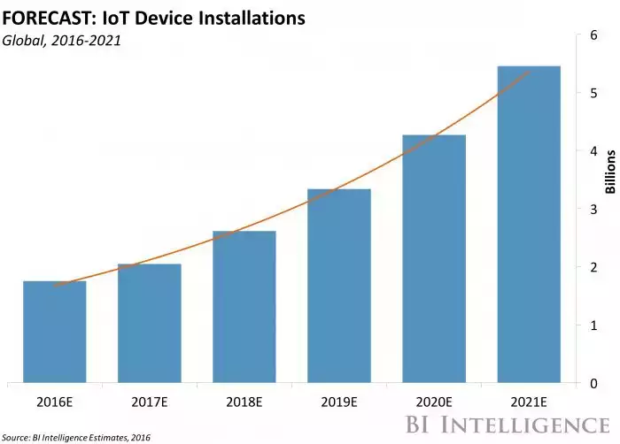

**Fig.1.1 IoT Increasing Usage**

With the great developments in the field of Internet and technologies, everything has become digital. Internet has become an important part of our lives. A new technology has entered into this picture known as Internet of Things (IoT).Internet of Things is a network comprises of many electronic devices and sensors which are connected together to exchange some information over the web. The devices based on IoT seem talking and sharing data with each other. It records the consumption and sends the readings to the utility office on regular basis for monitoring and billing. For a long time, traditional electromechanical meters have used Meter readings on the monthly basis. But now with the evolution of smart electricity meters, things are Changing.

Despite the benefits to both the providers and consumers of electricity, the electric devices may also introduce many outstanding security and privacy issues, especially when they are connected to public networks in which not only personally identifiable information but also energy consumption data relating to behaviours and movements of users is frequently exchanged and processed in large volumes.

**1.3 IoT WITH ELECTRIC METER**pasted-image.tiff

**Fig.1.2 Proposed Concept**

The figure also shows how this Internet of things can benefit from various cloud storage and processing services as long as security measures such as data encryption is implemented.

Furthermore, as the time interval of data collected by smart meters decreases to fifteen or thirty minutes, various load monitoring techniques can be employed to process unencrypted meter data to identify what electrical appliances, for example heaters, washing machines, refrigerators, air conditioners etc., are being used based on the electrical signature of those appliances shows a power consumption trace of a customer.

The security and privacy issues outlined above have prevented the cloud from reaching its full potential in supporting a smart grid, especially when many components of the grid are connected as an Internet of things via the public network. Electric devices are constrained devices having limited capacity and incapable of performing complex computing tasks on energy usage data.

Smart grids are envisioned by numerous and diverse stakeholders as the next-generation approach of delivering electricity to millions of households worldwide [1]–[6]. The smart grids have introduced computation and communication capabilities into traditional power grids to make them “smart” and “connected”. Processing chips and storage units have been embedded into traditional electricity meters, so that they are capable of performing “smart” functions. Then, smart meters communicate with electrical appliances at home as well as the generation and management facilities at the power companies, providing smart grids with great connectivity. Research and implementation on smart grids could be categorised at three layers [7]: “smart generation, smart grid, and smart customer.” With the intelligent and networked meters, the smart grids enable instant monitoring of power delivery and consumption information, subscription of power usage and controlling from remote, advanced demand and outage management, usage management especially with respect to pricing (e.g. charging electrical cars at non-peak hours), etc. Therefore, it benefits end-users as well as power generation and distribution. Moreover, smart electricity meters could be further linked with smart water and gas meters to better coordinate and manage energy usage for smarter/greener homes.

The smart grid has been conceived as an evolution of electric power systems due to the increasing diffusion of distributed generation by renewable sources, but with the additional aim to enhance efficiency, reliability and safety of the existing power grid. To this end, remote and timely information gathering about equipment failures, capacity limitations, and natural accidents is extremely critical for ensuring proactive and real-time and reliable diagnosis of possible failures in the smart grid. This makes cost-effective remote sensing technologies vital for safe, seamless and efficient power delivery in the smart grid. In this paper, communications technologies and requirements for smart grids have been discussed. Future work includes discussion of grid characteristics, architectures, key players, pilot projects, applications and research challenges on ICT issues, in order to give a complete overview on the subject.

Scientific computing requires an ever-increasing number of resources to deliver results for growing problem sizes in a reasonable time frame. In the last decade, while the largest research projects were able to afford expensive supercomputers, other projects were forced to opt for cheaper resources such as commodity clusters and grids . Cloud computing proposes an alternative in which resources are no longer hosted by the researcher's computational facilities, but leased from big data centres only when needed. Despite the existence of several cloud computing vendors, such as Amazon [4] and GoGrid [13], the potential of clouds remains largely unexplored. To address this issue, in this paper we present a performance analysis of cloud computing services for scientific computing. The cloud computing paradigm holds good promise for the performance hungry scientific community. Clouds promise to be a cheap alternative to supercomputers and specialised clusters, a much more reliable platform than grids, and a much more scalable platform than the largest of commodity clusters or resource pools. Clouds also promise to "scale by credit card, " that is, scale up immediately and temporarily with the only limits imposed by financial reasons, as opposed to the physical limits of adding nodes to clusters or even supercomputers or to the financial burden of over-provisioning resources. However, clouds also raise important challenges in many areas connected to scientific computing, including performance , which is the focus of this work.

The ability to network embedded devices with limited CPU, memory and power resources means that IoT finds applications in nearly every field. Such systems could be incharge of collecting information in settings ranging from natural ecosystems to buildings and factories, thereby finding applications in fields of environmental sensing and urban planning.On the other hand, IoT systems could also be responsible for performing actions, not just sensing things. Intelligent shopping systems, for example, could monitor specific users; purchasing habits in a store by tracking their specific mobile phones. These users could then be provided with special offers on their favourite products, or even location of items that they need, which their fridge has automatically conveyed to the phone. Additional examples of sensing and actuating are reflected in applications that deal with heat, water, electricity and energy management, as well as cruise-assisting transportation systems. Other applications that the Internet of things can provide is enabling extended home security features and home automation. The concept of an &quot; Internet of living things &quot has been proposed to describe networks of sensors that could use android interface to allow users to monitor agriculture. However, the application of the IoT is not only restricted to these areas. Other specialised use cases of the IoT may also exist. An overview of some of the most prominent application areas is provided here. Based on the application domain, IoT products can be classified broadly into five different categories: smart wearable, smart home, smart city, smart environment, and smart enterprise. The IoT products and solutions in each of these markets have different characteristics.

Although there has been much opposition to digital devices due to privacy and health concerns, it is obvious that they are here to stay and smart metering will be a “way of life” in the future. A number of different dimensions to smart meters have been highlighted including the smart meter technology and the process, the various stakeholders, existing analytics technologies and tools, and the current technological revolutions such as big data, cloud computing, and the IoT. The paper has also presented the current digital device space , their landscape, and then, a framework has been established to relate digital device data to stakeholders and applications created by their needs and the analytics tools and techniques required to achieve the stakeholder needs.

**CHAPTER 2**

**LITERATURE SURVEY**

**2.1 CLOUD BASED DATA STORAGE FOR SMART METERS USING IOT**

Smart grids introduce many outstanding security and privacy issues, especially when smart meters are connected to public networks, creating an Internet of things in which customer usage data is frequently exchanged and processed in large volumes. A cloud-based data storage and processing model with the ability to preserve user privacy and confidentiality of smart meter data in a smart grid. This goal is achieved by encrypting smart meter data before storage on the cloud using a homomorphic asymmetric key crypto-system. By applying the homomorphic feature of the cryptographic technique, we propose methods to allow most of the computing works of calculating customer invoices based on total electricity consumption to be done directly on encrypted data by the cloud.[5] Governments and energy suppliers are now able to balance electricity generation with consumption through a system of billing in which customers are charged by how much energy they have consumed at different times of day using dynamic and flexible tariffs. A decentralised security framework was designed for smart grids with the capabilities to do both data aggregation and access control. The smart grid is divided into a hierarchy comprising a home, building and neighbouring area networks. Electricity usage data is collected and sent to substations along a path from lower to higher networks in the hierarchy under the monitor and control of remote terminal units.

**2.1.1 BILLING**

A set of privacy-preserving protocols involving three parties: an electricity provider, a user agent and a simple tamper-evident meter. The data is encrypted by the smart meter using its symmetric key and stored in encrypted form in remote servers. To perform data aggregation and billing, the user will need to download the encrypted data and decrypt using a symmetric decryption key. The basic idea of developing MoBEBIS was to address some common issues related to the manual electricity billing process. Before suggesting this solution they were using a manual process on meter reading, amount calculation, and billing customer and so on. The interaction between customer and Electricity Board was very poor and it took much longer to respond to customer queries.[6]

The other major problem which was identified during the literature survey is that customers keep complaining that bills are incorrect. Most of the time bill calculation and system updating are done manually. There can be some resulting human errors to frustrated customers who are not satisfied about the service of the Electricity Board at all. Another difficulty observed was with making complaints against the Electricity Board service via a call.

The suggested system has come up with solutions which address all the above mentioned problems. With this service the burdens of the Meter reader as well as the Electricity Board get lessoned and are made more efficient. A mobile solution is given for the Meter reader so that the day to day work becomes less tiresome. Most of the manual processes and calculations are eliminated so that the meter readings can easily be collected more accurately to be updated to the system. On the other hand, the Android customers are also given a mobile solution so that they can view their latest bills, make complaints against the Electricity Board’s service, and make payments and other important tasks efficiently. Administration tasks of the Electricity Board can be easily done via a Web site which is provided as part of the complete project.

**2.1.2 HOMOMORPHIC KEY**

It allows specific types of computations to be carried out on cipher-text and generate an

encrypted result which, when decrypted, matches the result of operations performed on the plaintext. This feature has a great potential for cloud-based applications because not only users can encrypt and store their data on the cloud, but the encrypted data can also be processed directly on the cloud without compromising data privacy.

**2.2 METER DATA INTELLIGENCE FOR FUTURE ENERGY SYSTEMS**

Significant progresses have been made for using field data obtained from intelligent devices installed in substations, feeders, and various databases and models across the utility enterprises. With interoperability and the flexibility with technology independent systems and components, the environment is set for capturing data in near real time from multiple and diverse sources for generating data intelligence. Time-interval data provide more granular data opening up possibilities of trend and cycle analysis and different time of day consumption analysis. Time-interval-based consumption also enables to profile consumer behaviour and relate consumption to temperature changes. For retailers, the availability of vast volumes of data which could be used to profile and understand customers, their needs and behaviours enable better service provision and build stronger loyalty.[8] Better consumer awareness is expected to result in reduced energy consumption thus reducing the need for additional power plants which generate greenhouse gases. Restricting and reducing electricity usage during peak periods can result in cutting down on the need of using peeker plants which generally make higher carbon emissions. Load control feature in smart meters enables switching individual appliances ON and OFF as required. Retailers could offer this feature to customers when the cost of power is very high, while distributors could use it when a section of the network is close to capacity.

**2.3 SECURITY ACCESS AND MONITORING SYSTEM IN THE REAL TIME ENVIRONMENT**

The present electric power system structure has lasted for decades; it is still partially proprietary, energy inefficient, physically and virtually (or cyber) insecure, as well as prone to power transmission congestion and consequent failures. Recent efforts in building a smart grid system have focused on addressing the problems of global warming effects, rising energy-hungry demands, and risks of peak loads.[3] Security and privacy are critical to the development of wireless networks, especially for the real-time data audit strategy in smart grid. The smart grid interpretability panel cyber security working group presents some guidelines for smart grid cyber security, including security strategy, architecture, and high-level requirements.

In this research, we have designed and implemented a secure cloud-based data storage and processing model which can preserve user privacy and the confidentiality of smart meter data on a smart grid. Our research ensures that any smart grid can fully benefit from various cloud storage and processing services.

This is made possible by our homomorphic computing model using a homomorphic asymmetric key crypto-system to encrypt data, allowing the cloud to perform most of the computing works directly on encrypted data, specifically, the calculation of customer bills based on the aggregation of encrypted smart meter readings using fixed-point number arithmetics. With practical data from the Smart project, we have done many experiments to estimate the number of homomorphic additions to be performed on the cloud and measured the computation time in various billing periods. Our experiments show several factors that can influence the homomorphic computation time on the cloud such as the length of a billing period, the number of meters involved, or directly by the number of homomorphic addition operations.

**2.3.1 CRYPTO-TECHNIQUE**

Homomorphic Encryption encryption provides the addition and multiplication operations over cipher-texts; a user is able to process the plaintext without knowing the secret keys. With this property, homomorphic encryption is widely used in data aggregation and computation specifically for privacy-sensitive content. We review the homomorphic encryption scheme in which serves a building block of our proposed UDP scheme.

**2.3.2 DATA CONFIDENTIALITY**

The residential user can utilize symmetric or asymmetric cryptography to encrypt the data before outsourcing, and successfully prevent the unauthorised entities, including eavesdroppers and cloud servers, from prying into the outsourced data.

**2.3.3 DATA PRIVACY**

Individual residential users’ data should not be accessed by unauthorised requesters. It means that only requesters with authorised query tokens can access the CS2, and they can obtain the correct session keys when their query vectors in the tokens are satisfied with the encryption vectors. Thus, only the authorised requester can decrypt the encrypted metering data.

# **2.4 CLOUD COMPUTING FOR ENERGY MANAGEMENT**

Advanced metering infrastructure (AMI) is an integrated system of smart meters, communications networks, and data management systems that enables two-way communication between utilities and customers. In this survey, we provided an overview of existing works integrating cloud computing in the existing smart grid architecture, in order to have a reliable and efficient energy distribution. Different aspects of energy management in the smart grid were discussed. We identified some important technical issues and proposed several future research directions on cloud-based smart grid. Using cloud computing applications, energy management techniques in smart grid can be evaluated within the cloud, instead of between the end user’s devices. This architecture gives more memory and storage to evaluate computing mechanism for energy management, and cost optimisation. We proposed a new highlight on cost-effective cloud based power dispatching for smart grid applications. From this surveyed work, we can see the integration of cloud computing in smart grid is envisioned to be useful for evolving the smart grid architecture further in terms of considerations such as monitoring cost, computing, and power management.

This is made possible by our homomorphic computing model using a homomorphic asymmetric key crypto-system to encrypt data, allowing the cloud to perform most of the computing works directly on encrypted data, specifically, the calculation of customer bills based on the aggregation of encrypted smart meter readings using fixed-point number arithmetics. With practical data from the Smart project, we have done many experiments to estimate the number of homomorphic additions to be performed on the cloud and measured the computation time in various billing periods. Our experiments show several factors that can influence the homomorphic computation time on the cloud such as the length of a billing period, the number of meters involved, or directly by the number of homomorphic addition operations.

**2.4.1 ON-DEMAND SELF-SERVICE**

A consumer can individually provision computing capabilities as· needed automatically without requiring human interaction with each service provider. [10] Broad network access: Capabilities are available over the network. It can be accessed through· standard mechanisms, to be used by heterogeneous thin or thick client platforms.

Virtualisation technology can be used in cloud computing that can take a variety of different types of computing resources as abstracted services to users. These cloud services are divided into Infrastructure-as-a-Service (IaaS), Platform-as-a-Service (PaaS) and Software-as-a-Service (SaaS).

**CHAPTER 3**

**COMPONENTS**

**3.1 ARDUINO BOARD AND BENEFITS**

Arduino is an open-source electronics platform based on easy-to-use hardware and software. Arduino boards are able to read inputs - light on a sensor, a finger on a button, or a Twitter message - and turn it into an output - activating a motor, turning on an LED, publishing something online. You can tell your board what to do by sending a set of instructions to the micro-controller on the board. To do so you use the Arduino programming language (based on Wiring), and the Arduino Software (IDE), based on Processing.

Over the years Arduino has been the brain of thousands of projects, from everyday objects to complex scientific instruments. A worldwide community of makers - students, hobbyists, artists, programmers, and professionals - has gathered around this open-source platform, their contributions have added up to an incredible amount of accessible knowledge that can be of great help to novices and experts alike. All Arduino boards are completely open-source, empowering users to build them independently and eventually adapt them to their particular needs. The software, too, is open-source, and it is growing through the contributions of users worldwide.

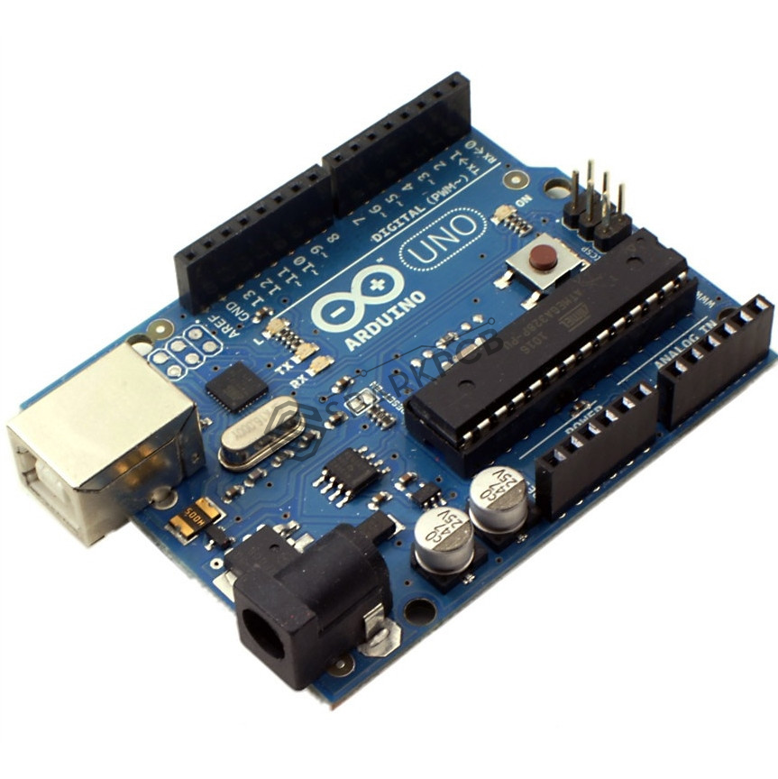

Arduino has simple and accessible user experience and has been used in thousands of different projects and applications. The Arduino software is easy-to-use for beginners, yet flexible enough for advanced users. It runs on Mac, Windows, and Linux. Teachers and students use it to build low cost scientific instruments, to prove chemistry and physics principles, or to get started with programming and robotics. Designers and architects build interactive prototypes, musicians and artists use it for installations and to experiment with new musical instruments. Makers, of course, use it to build many of the projects exhibited at the Maker Faire, for example. Arduino is a key tool to learn new things. Anyone - children, hobbyists, artists, programmers - can start tinkering just following the step by step instructions of a kit, or sharing ideas online with other members of the Arduino community. The Benefits are,

* Inexpensive
* Cross-platform
* Simple, clear programming environment
* Open source and extensible software
* Open source and extensible hardware

**Arduino in e-Salvage Project**

Arduino in our project is used to note the electric meter reading and send it to the gsm module, that is attached to it. We used Arduino uno module to make connection with the sim900A. It mainly used to receive the meter reading as a input it. Now this data is sent to the GSM Module which is in connection with it. Initially, the related code is entered in the arduino IDE and uploaded in the board. The time interval for the data fetching is based on the user wish. It can be altered in the coding if needed.

**3.2 SIM900A - GSM MODULE**

Using this module, we can make audio calls, send and read SMS, attend the incoming calls and internet etc through simple AT commands. **SIM900A** is used to connect the arduino to the mobile phone, it will send the readings of power consumed through an application. With which the consumer will be able to know his readings.

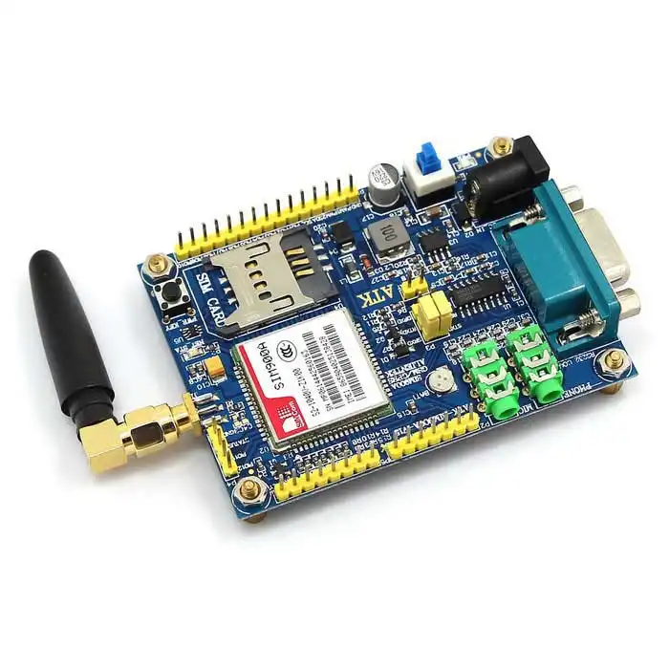

A **SIM900A GSM Module** is basically a GSM Modem (like SIM 900) connected to a PCB with different types of output taken from the board – say TTL Output (for Arduino, 8051 and other microcontrollers) and RS232 Output to interface directly with a PC (personal computer). The board will also have pins or provisions to attach mic and speaker, to take out +5V or other values of power and ground connections. These type of provisions vary with different modules.

Lots of varieties of GSM modem and GSM Modules are available in the market to choose from.

For our project of connecting a gsm modem or module to arduino and hence send and receive sms using arduino – always good to choose an ***arduino compatible GSM Module*** – that is a GSM module with TTL Output provisions. The main usage of this module is to send the received input to the android app in order to feed into the cloud. The data is encrypted, so it is fine to transmit safely. The essential thing for the transmission is the respective mobile number which is get registered with the app. Hence it is easy to track the data.

**3.3 GOOGLE FIRE BASE**

Firebase has grown inside Google and expanded their services to become a unified platform for mobile developers. Firebase now integrates with various other Google services to offer broader products and scale for developers.

#### **Firebase Cloud Messaging**

Formerly known as Google Cloud Messaging (GCM), is a cross-platform solution for messages and notifications for Android, iOS, and web applications, which currently can be used at no cost.

#### **Realtime Database**

Firebase provides a realtime database and backend as a service. The service provides application developers an API that allows application data to be synchronised across clients and stored on Firebase's cloud. The company provides client libraries that enable integration with Android, iOS, JavaScript, Java, Objective-C, swift and Node.js applications. The REST API uses the Server-Sent Events protocol, which is an API for creating HTTP connections for receiving push notifications from a server. Developers using the realtime database can secure their data by using the company's server-side-enforced security rules.

#### **Firebase Storage**

Firebase Storage provides secure file uploads and downloads for Firebase apps, regardless of network quality. The developer can use it to store images, audio, video, or other user-generated content. Firebase Storage is backed by Google Cloud Storage.

#### **Firebase Notification** is a service that enables targeted user notifications for mobile app developers at no cost. Firebase is used in our project to store the large amounts of data that we get as notifications and readings. We will be able to retrieve all the data back once it is required.

**CHAPTER 4**

**PROBLEM DEFINITION**

The Consumption of electricity varies based on the usage of the requirement. The existing system can only read and sense the data from the electricity meter. If the user is given a threshold value he/she would be asses his needs and consume less power. This reduces the power consumptions which takes place without the knowledge of the stakeholder. With this data provided the stakeholder can also switch to green power gadgets and led bulbs which consume very less power.

With the data available, the renters could easily monitor the power consumed by the every tenant and need not go to their property directly. The development digital technology helps the users to monitor and manage electricity from all generation sources to meet the varying electricity demands. This reduces the work and time of shop/house owners who go there to enquire about their power consumption and sometimes collect cash. This mechanism/process would be really helpful to renters who own more properties. The Advantages are,

* Easy monitoring (Very useful for renters who own multiple properties)
* Accurate Information
* Speedy Information

**CHAPTER 5**

**DESIGN OF PROPOSED SYSTEM**

The Basic structure of this implementation is based on the physical and network connection of the modules.

**5.1 DATA FLOW DIAGRAM**

The Data Flow Diagram consists of the different levels of the system. Each level portrays about its specifications and the necessary options available.

**5.1.1 LEVEL 0**

APP

USER

**Fig.5.1 DFD level 0**

In this level 0, the basic outlook of the design. It includes the gist of the required module.

**5.1.2 LEVEL 1**

**APP**

Interface

Statistics

**USER:**

ID-1

ID-2

**Fig.5.2 DFD level 1**

This level helps in identifying the functionalities and the types of characteristics available to the end-user in order to access the features.

**5.1.3 LEVEL 2**

This level includes the extra features that is present inside the features of the Level 1 functionalities.

**USER**

- requests statistics

-view graph

-monitor ID

**APP**

- structural view

-graphical display

**Fig.5.3 DFD level 2**

**5.2 SCHEMA OF PROPOSED SYSTEM**

|  |  |
| --- | --- |
| ATTRIBUTE | TYPE |
| username | varchar |
| number | int |
| password | varchar |
| address | varchar |
| Meter ID | int |
| Target Value | int |
| Meter Output | int |

**Table 5.1Schema**

**5.3 FLOWCHART OF IMPLEMENTED MODULE**

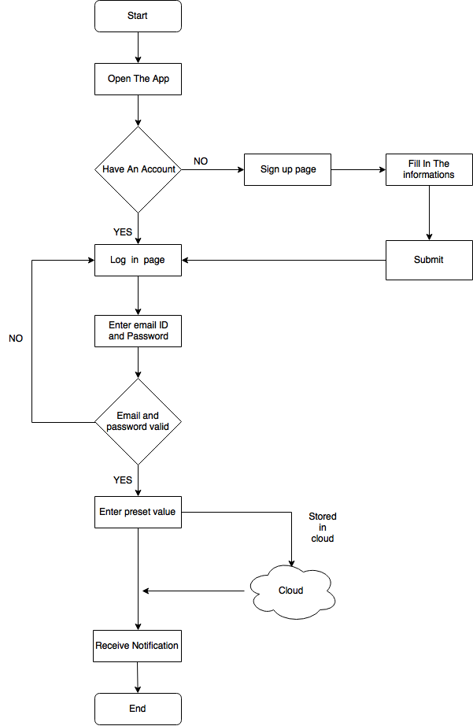

**Fig.5.4 flowchart**

**CHAPTER 6**

**IMPLEMENTATION OF PROPOSED SYSTEM**

The meter is connected to internet and the app is also connect to the internet, the app can be installed in any smartphone. The app consist of the user interface in which the users can interact with the app to know about the readings about the meter. The app first opens the signup page, this page consist of many fields like name mail id , phone number, address, city, state and some basic information.The users those who are new will fill in the fields and then confirm that the given fields are true and they will verify that. Now these datas will be stored in a database and that database will be managed by an admin.secondly the user those who have already enrolled will login in the app with the userID and the password that they have entered in the signup process.The fields will be checked with the datas in the database and if the fields match ,the account will be logged in and if not it will prompt error message.there will be a certain limit of tries and if exceeded the limit the account can be logged in only after some particular time.The user can have many meter id in one account so it is convenient for the user to monitor multiple electricity consumption of his property in one app. The next page after login is the main user interface where the user can observe the electricity usage in his dashboard. The data will be show in the form of circular data analysis where the circle is the full limit set by the user and the darken part in the circle in the circled way is the electricity consumed out the full circle so the left out part of the circle is the remaining electricity of the limit set. This circle will vary in size depending upon the limit we set on the consumption of electricity. The circle will be viewed for each meter id separately.

There will be tabs on the top of the app interface and each tab will be indicated as the meter 1 and more upto how much they have. For the each tab there will be separate data display analysis and the limits can be set to each meters and they can be different from each other and that is completely depends upon the users opinion. There will be plus symbol at the right hand top side of the app in the main user interface. That helps to set reminders when a certain limits are reached and then the user will be notified through the app that the particular limit has been reached. This process is performed using IOT and the devices (ie. meter and app) should be connected to the internet so that the datas can be synced or read from the meter and synced to the app with the id the user used. The security is encrypted to the datas that are transmitted through the cloud and that datas are encrypted when transferring of data in the internet.In the app there are three analysis in which the first one shows the meter reading as in the meter as a speedometer the second one shows the usage for a day and the third one shows the readings appropriate to the limits that the user entered.The user can benefit these analysis from the app user interface.

**6.1 HARDWARE MODULE**

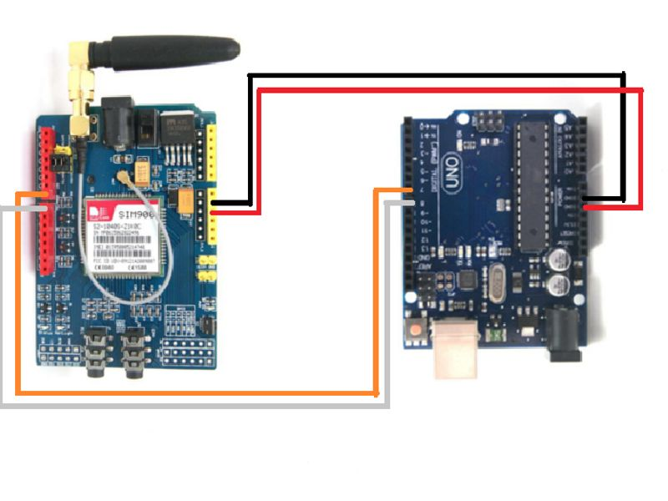**Fig.6.1 Hardware Modul**e

The Arduino Board is connected with the SIM900A GSM module as shown in fig.5.2. The connection is established as they are intended to transfer valuable among them. This setup is made in order to transmit the meter reading from the electric meter to the arduino and then to the gsm module. GSM module sends the incoming data as a message to the app module.

Initially, a 2G sim which is used to transmit value as message is inserted in the gsm module. The corresponding code is uploaded into the arduino and when the input is fed into it then the gsm senses the data and sends it to the app. In this project, the data is sent as a encrypted one for safety measures.

**6.2 APP MODULE:**

**6.2.1 LOGIN*:***

The login page consist of two fields, the user id field and the password field. The login credentials are verified with the database to ensure the privacy and security for the user’s account. The fields that are entered in the login page are checked with the database to see how they match,Then the account should be logged in otherwise error message is shown.

**6.2.2 REGISTRATION*:***

The registration module is used to create an account for the meter monitoring service and the analysis on the readings. The registration module consist of various fields such as name, email id, password, phone number, address and meter id. The user will enter the fields and the information is confirmed by a confirmation mail. The user id and the password and the other fields are saved in the database with high security and the database is updated whenever the changes are made by the user in their unique user id. The fields will be used to verify the login. If the login informations are incorrect then the account will fail to open whereas if the informations are correct then the account will be logged in.

Additional feature is made to categorise the user preference, that is the user can have access to different databases based on the id. For example; A User may have rented two or more houses, in order to monitor the electric usage of the rentals, this ID will be useful. Since the user ID is unique, this functionality is made possible to observe the various data.

**6.1.3 APP INTERFACE*:***

This interface mainly consist of meter readings and the analysis of the reading. The data are fetched from the cloud to the app manually or even the fetching rate can be adjusted in the settings according to one’s perspective. The limits are set in the app through the cloud based service and IOT, the user will be notified in the app once the limit has been reached.

The number of watts used and the number of watts remaining corresponding to the limit set can also be observed from the app. This will enhance the user well with the knowledge of their consumption of electricity. The app allows the user to add multiple meter id in a same user id incase if they have more than one property with this smart meters. Similarly the multiple meter can have different limits according to the users intentions.For example a flat owner can monitor multiple houses from a mobile app and can view the current consumption rate for each and every single house that is present in the flat.

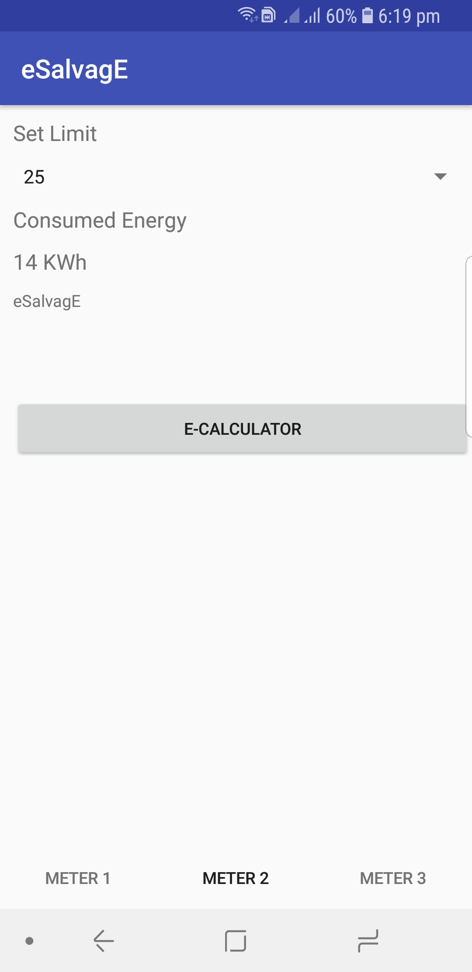

**Fig.6.2 User Interface**

**COST:**

The Total cost required for this project to implement is about Rs.2000 (approx.,). If the required components are purchased as a mass count and integrated for more installations, the total cost may be reduced for individual component.

**CHAPTER 7**

**CONCLUSION**

A comprehensive survey of transferring and retrieval of data between a sensor and an application with the help of IoT and Cloud computing has been presented. The digital devices will be used in every walk of life in the near future and data acquired should be handled with care. This is made possible by our homomorphic computing model using a homomorphic asymmetric key crypto-system to encrypt data and allowing the cloud to perform most of the computing works directly on encrypted data[**1**]. A number of different dimensions have been highlighted including the various stakeholders, existing analytics technologies and tools, and the current technological revolutions such as big data, cloud computing, and the IoT [**9**].

Eventually it clearly presents how the stakeholders would be able to know their power consumption via the app and can monitor their daily needs to consume less; all the work done manually leading to several misinterpretations and miscalculations will not be needed once we have accomplished this digitally. Stakeholders could choose to change to LED bulbs, Solar heaters and other devices which consume less power thereby reducing their energy costs.

**SOURCE CODE**

**1. LOGIN PAGE**

package com.example.sai.avinash;

import android.content.Intent;

import android.support.v7.app.AppCompatActivity;

import android.os.Bundle;

import android.view.View;

import android.widget.Button;

import android.widget.EditText;

import android.widget.Toast;

public class LoginPage extends AppCompatActivity implements View.OnClickListener {

EditText user,password;

Button login,signup;

@Override

protected void onCreate(Bundle savedInstanceState) {

super.onCreate(savedInstanceState);

setContentView(R.layout.activity_login_page);

user=(EditText)findViewById(R.id.UserNameEditText);

password=(EditText)findViewById(R.id.PasswordEditText);

login=(Button)findViewById(R.id.Loginbutton);

signup=(Button)findViewById(R.id.SignUpbutton2);

login.setOnClickListener(this);

signup.setOnClickListener(this);

}

@Override

public void onClick(View view) {

String s1,s2;

s1=user.getText().toString();

s2=password.getText().toString();

if(view==login)

{ if(s1.equals("admin")&&s2.equals("admin"))

{

Intent newpage=new Intent(getApplicationContext(),LoggedPage.class);

startActivity(newpage);

finish();

}

else

{

Toast.makeText(this,"Incorrect password",Toast.LENGTH_LONG).show();

}

user.setText("");

password.setText("");

}

else if(view==signup)

{

Intent signuppage=new Intent(getApplicationContext(),SignUpPage.class);

startActivity(signuppage);

user.setText("");

password.setText("");

}

}

}

**2. ARDUINO**

#include <SoftwareSerial.h>

SoftwareSerial mySerial(9, 10);

char msg;

char call;

void setup()

{

mySerial.begin(9600); // Setting the baud rate of GSM Module

Serial.begin(9600); // Setting the baud rate of Serial Monitor (Arduino)

Serial.println("GSM SIM900A BEGIN");

Serial.println("Enter character for control option:");

Serial.println("s : to send message");

Serial.println();

delay(100);

}

void loop()

{

if (Serial.available()>0)

switch(Serial.read())

{

case 's':

SendMessage();

break;

}

if (mySerial.available()>0)

Serial.write(mySerial.read());

}

void SendMessage()

{

int i=40;

i=(i*3)+7; //encrytion

mySerial.println("AT+CMGF=1"); //Sets the GSM Module in Text Mode

delay(1000); // Delay of 1000 milli seconds or 1 second

mySerial.println("AT+CMGS=\"+918903335151\"\r"); // Replace x with mobile number

delay(1000);

mySerial.println(i);// The SMS text you want to send

delay(100);

mySerial.println((char)26);// ASCII code of CTRL+Z

delay(1000);

}

void ReceiveMessage()

{

mySerial.println("AT+CNMI=2,2,0,0,0"); // AT Command to recieve a live SMS

delay(1000);

if (mySerial.available()>0)

{

msg=mySerial.read();

Serial.print(msg);

}

}

void MakeCall()

{

mySerial.println("ATD+91905026828;"); // ATDxxxxxxxxxx; -- watch out here for semicolon at the end!!

Serial.println("Calling "); // print response over serial port

delay(1000);

}

**3. METER ACTIVITY**

package com.example.sai.avinash;

import android.Manifest;

import android.content.Intent;

import android.content.pm.PackageManager;

import android.support.v4.app.ActivityCompat;

import android.support.v4.content.ContextCompat;

import android.support.v7.app.AppCompatActivity;

import android.os.Bundle;

public class MainActivity extends AppCompatActivity {

Thread splash;

@Override

protected void onCreate(Bundle savedInstanceState) {

super.onCreate(savedInstanceState);

setContentView(R.layout.activity_main);

int permissionCheck = ContextCompat.checkSelfPermission(this, Manifest.permission.READ_SMS);

if (permissionCheck == PackageManager.PERMISSION_GRANTED) {

//showContacts();

} else {

ActivityCompat.requestPermissions(this, new String[]{Manifest.permission.READ_SMS}, 100);

}

splash=new Thread(){

public void run()//calling the run function to start the thread activity

{

try

{

sleep(5000);

//creating an intent to show next page after 3 seconds of splash screen

Intent mySecondPage = new Intent(getApplicationContext(), LoginPage.class);

startActivity(mySecondPage);

finish();

}

catch(Exception e)

{

e.printStackTrace();

}

}

};splash.start();

}

}

**SCREENSHOTS**

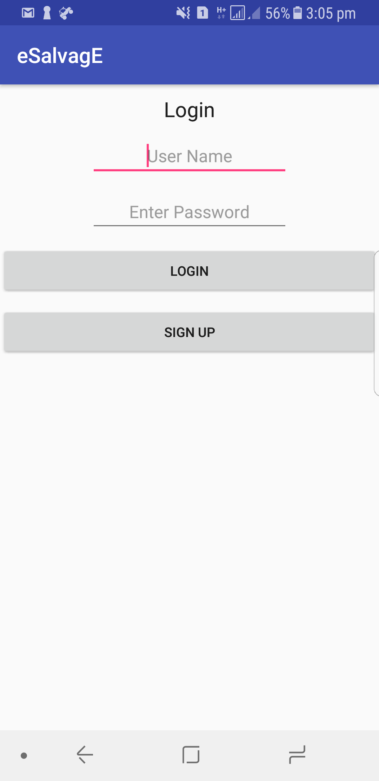

**a2.1 Login page**

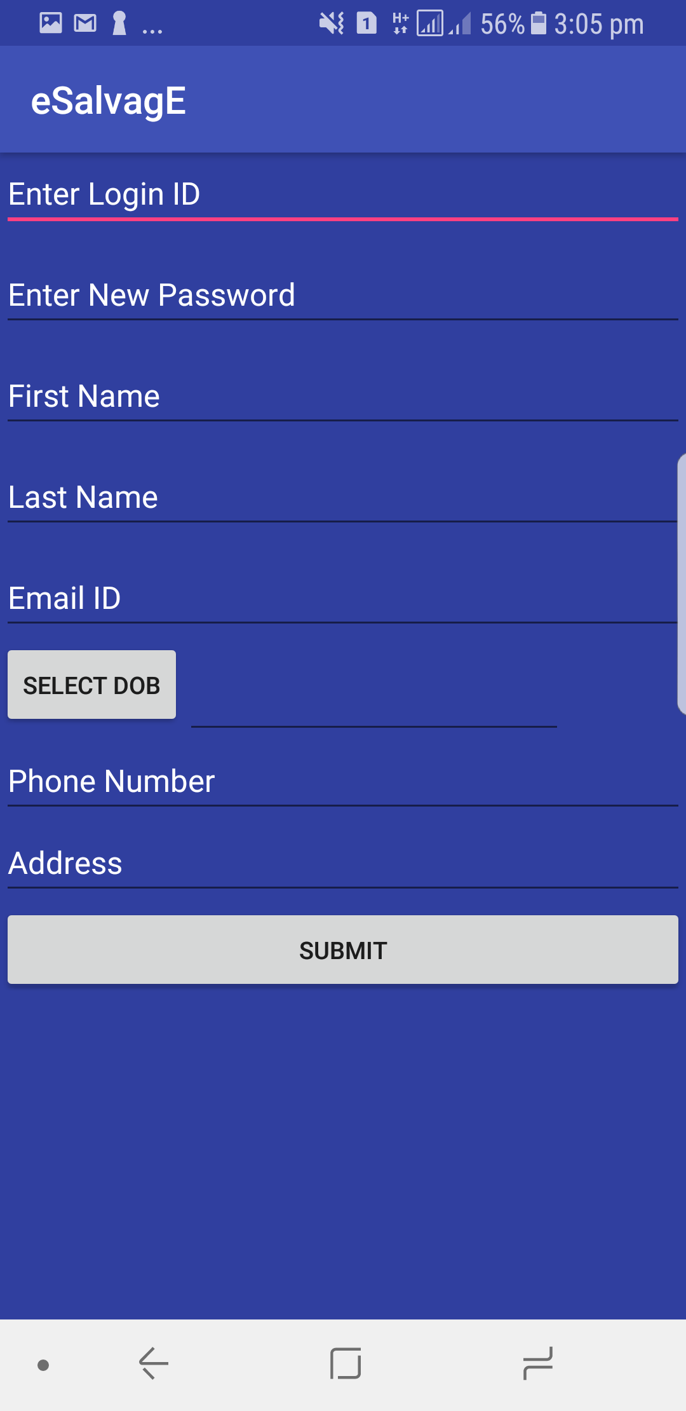

**a2.2 Sign-up**



**a2.3 Main page**

**REFERENCES**

[1] Vu Mai , Ibrahim Khalil , Future Generation Computer Systems 72 (2017) 327–338

[2] Steven M- Ward, El Paso, Tex, Electric meter consumption and demand communicator , US 4350980 A

[3] Mell P and Grance T 2011 The NIST definition of cloud computing (USA:National Institute of Standards and Technology)

[4] In Lee*,Kyoochun Lee, Internet of Things (IoT): Applications, Investments, and Challenges for enterprises, Business Horizons (2015) 58, 431—440

[5] E.L. Quinn, Smart metering and privacy: Existing laws and competing policies, SSRN eLibrary.

[6] C.-I. Fan, S.-Y. Huang, W. Artan, Design and implementation of privacy preserving billing protocol for smart grid, J. Supercomput. 66 (2) (2013) 841–862.

[7] G. Acs, C. Castelluccia, I have a dream!(differentially private smart metering), in: Information Hiding, Springer, 2011, pp. 118–132.

[8] M. Weiss, A. Helfenstein, F. Mattern, T. Staake, Leveraging smart meter data to recognize home appliances, in: 2012 IEEE International Conference on Pervasive Computing and Communications (PerCom), IEEE, 2012, pp. 190–197

[9] Damminda Alahakoon, Member, IEEE, and Xinghuo Yu, Fellow, IEEE, IEEE Transactions on Industrial Informatics, Vol.12, No.1, February, 2016

[10] M. Zeifman, K. Roth, Nonintrusive appliance load monitoring: Review and outlook, IEEE Trans. Consum. Electron. 57 (1) (2011) 76–84.